
Student’s name |  | Grade | 6
Subject | Computer | Week No. | 2
Lesson Title | Pictograms | Unit
Instruction: Identify the meaning of the following signs

- 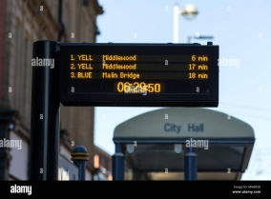 2. 

_____________________________ _____________________

3.  4. 
________________________ ______________________

5. 
________________________
Good Luck

